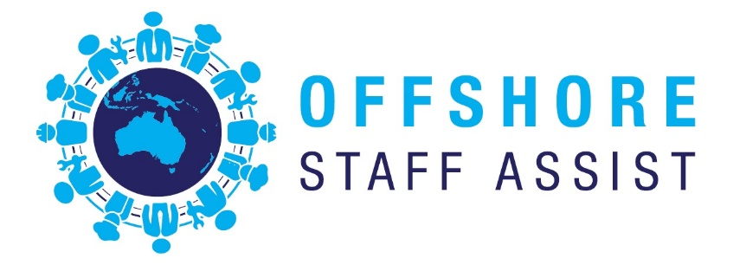

***Offshore Staff Assist*** is an Australian owned company based in Perth, Western Australia with international affiliation to over 10 countries, and is a specialist Recruitment Agency with a unique approach to solving client staffing problems.

Our focus is on providing an honest and reliable service to both the client and the jobseeker. With global mobility of multinational workforce, ***Offshore Staff Assist*** provides the missing link that connects flexible employment opportunities for both client and applicant in finding a perfect career match.

With firsthand experience in both business ownership and management and with over 20 years of industry experience we understand that a stable and reliable staff is the key to operating a successful business by reducing your turnover costs and time lost by HR issues.

With this knowledge and a relationship with a Migration Agent and a Registered Training Organisation ***Offshore Staff Assist*** has developed an all-encompassing off shore recruitment and staffing plan that will suit either your short or long-term business model.

With a strong commitment to “process” and a focus on achieving exceptional results for our clients, ***Offshore Staff Assist*** can offer a clear recruitment pathway, with precise outcomes, to ensure our clients businesses continues to grow in the right direction

**David Bergl – Managing Director**

David is professional with 15 years Recruitment and Human Resources experience and various management roles, spaning across a wide variety of industry sectors .

Adding to David’s recruitment experience he also has over 20 years of experience in the mining industry from a range of open pit mining operations to various mineral processing and fixed plant operations in Australia, Asia and Africa. He also brings with him a strong knowledge in Health, Safety, Environmental and Quality system which has included the creation and implementation of ISO systems for companies and a durable history in Health and Safety consulting

With a strong background in business development, David has been involved in the creation of numerous mining sites and associated consulting companies and also was the founding owner of a start-up international recruitment company that was successfully floated on the ASX.

**Paget – Botswana – Zimbabwe**

Paget has a background in both permanent and contract recruitment spanning both local and international sectors and has worked across many vendor environments specialising in blue collar recruitment to Australia.

Prior to his career in recruitment, Paget spent 10 years working for one of Africa’s largest marketing consultant’s companies. This Marketing and Sales experience combined with the recruitment experience has given Paget a strong understanding of an ever-changing recruitment market.

**Adison Suriwayana - Indonesia**

Adi has been involved in recruitment since 1997 in both Indonesia and Australia. He has worked in large and small recruitment companies including large corporate organisations and has a thorough understanding of the calibre of people required for specific roles.

As well as being a Director, Adison provides guidance and support to our clients wishing to explore recruitment opportunities from Indonesia